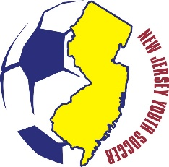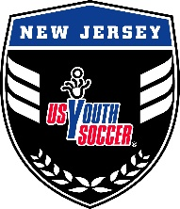

2017 NJ YOUTH SOCCER OLYMPIC DEVELOPMENT PROGRAM TRYOUT REGISTRATION: JULY 30-31 & AUGUST 13-14

Open tryouts for NJ Youth Soccer’s 2017 Olympic Development Program (ODP) will be held Saturday and Sunday, July 30-31 and August 13-14 in 2016 for players born in years 2000 through 2004. Times by age group will be confirmed and communicated later this month. Different from past years, the initial round of tryouts will take place throughout the state to make the program more accessible:

Saturday, July 30th: Nutley (north)
Sunday, July 31st: Wall (shore)
Saturday, August 13th: Mullica Hill (south)
Sunday, August 14th: Ewing (central)
Click here to register. Like last year, the registration fee for the tryouts is $40 and qualifies players for all four sessions. Players are strongly encouraged to attend as many sessions as possible. Attending only one session may hinder a player’s chance of being identified due to lack of time in front of our evaluators. Details about the various area tryouts, such as address and tryout times by age group, are posted on the ODP page of www.njyouthsoccer.com.
The goal of this initial tryout process is to identify a pool of players and invite them to participate in a second round of tryouts where players will be further evaluated. The format for this second and subsequent stages will vary by age group. Participation in last year’s tryouts grew by more than 30% and some age groups had more than 100 players so the identification process has been revised to account for a growing interest in the program. “Having been a part of ODP growing up, I understand the advantage that it can provide in a young player’s development,” said Mike Petke, NJYS Director of ODP and Player Development. “This format change will help us accomplish two key objectives; to engage players in underrepresented areas of the state, and to improve the evaluation process, thus ensuring top quality talent is identified.”
ODP is not in in competition with club soccer, but rather is a way to supplement player development, making players more effective for their respective clubs. In addition, ODP provides direct access to college coaches on the staff, at summer tournaments, and at ID camps. “ODP has provided me and other college coaches exposure to top talent in NJ,” said Dan Donigan, Rutgers University men’s soccer head coach and ODP Committee member. “ODP is a proven pathway for players to compete at the college level as demonstrated by the men and women who have played here at Rutgers.”
Ultimately, NJYS ODP will select a group of elite male and female players from each age group to form the final state team that trains and competes in the spring and summer of 2017. State team players will be considered for U.S. Youth Soccer Region I teams, which may offer opportunities for international competition. In recent years, selected NJ players have traveled to Spain, Italy, Germany, and Costa Rica for competition. Girls and boys selected for the Regional ODP team pools are also candidates for the U.S. National Team selection process.
Candidates are evaluated in four key areas: Technique, Insight, Mindset and Athleticism. Players will be selected by NJ Youth Soccer ODP coaches who have been recognized for their ability to identify and train players with superior skills.

