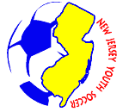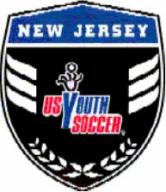
NJYS and ODP Development Process
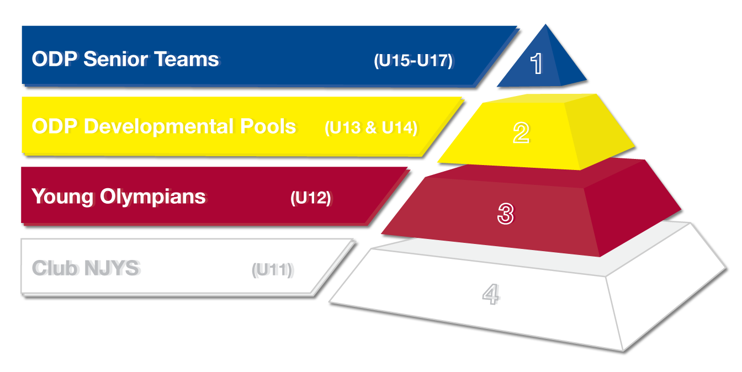

OVERVIEW
Beginning with Club NJYS and the Young Olympians program, the NJYS Olympic Development Program (ODP) strives to be a 7-year journey for any youngster that aspires to play at the highest level and, one day, wear the colors of the United States of America in international competition and/or their dream club. Every stage in the NJ Youth Soccer player development program will assist with human and soccer development. NJYS strives to:
- provide the highest quality staff, facilities, environment and curriculum to give players the tools to succeed
- promote a growth mindset ideally leading to the players revealing their true self-image, values, character, and passion for the game
- provide opportunities to play soccer in a supportive and rewarding environment

NJYS ODP Playing Philosophy
NJ Youth Soccer believes in playing open, creative, attacking soccer that encourages players to express themselves. Ball possession and circulation are emphasized, with attacks built up from the back and players interchanging their positions, as dictated by the game. Aimless kicking, dependence on long balls, and overreliance on physical play are discouraged. Besides competitive, skillful and intelligent problem solvers, we will constantly seek and encourage players who provide good support play around the ball, patience and composure on the ball.

STATE ODP TEAM
State ODP Teams in various age groups are assembled from the top performing players from around the state. Pools of players are identified in each eligible age group and brought together as a team to further develop their skill by training and competing at a variety of events.
Last year, there were more than 1,000 players that entered the first round of ODP tryouts. For that reason, we have implemented a staged process to best ensure that players are appropriately identified for this elite program. As a non-profit entity, NJ Youth Soccer makes every effort to avoid increasing the relative cost of the program.
For last year’s State ODP Teams, the 1999-2001 age groups each had one State ODP Team of approximately 20 players, and the 2002-2003 age groups each had two State ODP Teams of approximately 20 players. These numbers may represent this year’s program, but they are subject to change in accordance with the talent level in this year’s pool of players.
Eligibility: Birth years 2000 through 2004 boys and girls (tryouts open to all players in these age groups)

Tryout (1st Stage): This 1st round of tryouts consists of sessions where players of all levels are randomly placed into teams competing in match condition activities for purposes of identifying a pool of players to qualify for the second stage of the tryout process. There are four tryout dates, and players are expected to attend as many as possible. Attending only one session may hinder a player’s chance of being identified because of our evaluator’s limited time observing play and potential. The cost is $40, and registrants will be eligible for all four sessions.

Tryout (2nd Stage): The 2nd stage of the tryout process consists of three outdoor evaluation sessions in November and December. These sessions allow our State ODP Coaches to assess and expose "similarly skilled" players to a variety of soccer situations they will likely experience at the State ODP Team level. The cost is $50, and registrants will be eligible for all three scheduled sessions. Players will be refunded money if more than one session is cancelled by NJYS (e.g. weather).

Tryout (Final Stage): The final stage of the tryout process consists of three outdoor trainings in January and February and the Virginia Friendlies also in February. Participation in all events is strongly encouraged, but not mandatory. Evaluations will occur at all sessions/games and will allow the ODP coaching staff a final look to evaluate in small groups while also training within the principles of the game. The cost for the NJ trainings is $100 and will include an NJYS ODP shirt. Players will be refunded money if more than one session is cancelled by NJYS (e.g. weather).

The Virginia Friendlies is an event hosted by Virginia Youth Soccer for boys birth years 2000 through 2004 and girls birth years 2003 and 2004. It includes three 11v11 "friendly" matches against other USYS Region I (northeast) and Region III (southeast) State ODP Teams. This is the final event before our final State ODP Team is identified and offers players the opportunity to be further assessed by our State ODP Team coaches in a "competitive cauldron" in front of other State ODP Coaches and Regional Coaches. These Friendlies include an added expense (last year’s fee was $150).

The final round evaluations will give our State ODP Team coaches one final look in a more intense and challenging environment before selecting our State ODP Team.

State ODP Team: From mid-April through mid-June, our State ODP Team will train together and expose "similarly skilled" players to the National ODP Curriculum, our style of play and a variety of soccer situations and positional roles. Players on the State ODP Team will also compete in scrimmages against State ODP Teams of other age groups, in the Region I ODP Tournament and are eligible to participate in the Region I ID Camp. There is an added expense to participate in these competitions and events. (Fee: To be announced)

State ODP Pool (2004 boys and girls): Players identified for the State ODP Pool will participate in multiple training sessions and games starting in early April. State ODP Pool players who are not initially selected for the State ODP Team will remain eligible for the State ODP Team based upon their quality of play in further State ODP Pool training sessions and other factors (e.g. spots vacated). State ODP Pool players not selected to the State ODP Team may still have the opportunity to play in the Region I ODP Tournament, and the fee would cover this expense as well as the State ODP Pool training sessions. (Fee: To be announced)

Play Days (2000-2002 boys and girls): These State ODP Teams will be invited to participate in a Play Day, which will consist of round-robin friendly matches in preparation for the Region I ODP tournament, which will take place the following weekend (additional fee applicable).

NJYS ODP Mini Camp (2003 and 2004 boys and girls): Traditionally held approximately one weekend prior to the Region I ODP Tournament weekend, this is a one weekend overnight event consisting of a series of training sessions, match conditioned activities and games designed primarily to prepare our State ODP Teams for the Region I ODP Tournament (additional fee applicable).

REGION I ODP TEAM

US Youth Soccer Region I Teams are assembled from the top performing pools of players that are identified from the 15 State ODP Teams in each eligible age group and brought together as a team to further develop their skill by training and competing at a variety of regional, national and international events.

Region I ODP Tournament (2000-2004 boys and girls): The US Youth Soccer Region I ODP Tournament is a competitive event held in June where players are observed by Regional and National coaches and scouts. The 2003 and 2004 teams play in a round-robin format. The 2000-2002s play in a Championship Format where the Region I Champions for the 2001 and 2002 teams qualify to compete in the US Youth Soccer National ODP Championships held in early Spring of the following year. The group phase is usually held the first weekend in June while the semis and finals for the 2000-2002s are held two weekends after in Delaware. The cost of this event is included in the NJYS ODP program fee.

Region I ODP ID Camps: This is the final phase of the girls NJYS ODP Season (second to the last phase of the boys NJYS ODP Season). This overnight camp that takes place over a weekend (or a series of weekdays) usually in late July where players from a variety of Region I ODP State Associations born in the same year are randomly scrambled into teams, train together and compete while being assessed by Regional and National Coaches. This camp is also used to identify a pool of players for the Region I pools and teams that may travel to play internationally. Some girls age groups also identify representatives for National Camp call ups (additional fee applicable).

Region I Boys ODP Call Back Camp: This is the final phase of the boys NJYS ODP Season. This is an overnight camp that takes place over a weekend (or a series of weekdays) where players who were identified at the July Region I ID Camps are randomly scrambled into teams, train together and compete in games for the purpose of identifying a pool of players for the Boys Regional Pools and Teams that may travel to play internationally (additional fee applicable).

US Youth Soccer Girls ODP Inter-regionals (2000-2004 girls): This is a competitive event that takes place Thanksgiving week and weekend for Region I Teams. Players on these teams are invited by the Region I ODP Coaches. The teams will train and play in a Festival Format, and their performance will be assessed by National ODP Staff Coaches and scouts. This is a pathway to the Youth National Teams (additional fee applicable).

US Youth Soccer Boys ODP Inter-regionals (2000-2002 boys): This is a competitive event that takes place week before Christmas for Region I Teams. Players on these teams are invited by the Region I ODP Coaches. The teams will train and play in a Festival Format, and their performance will be assessed by National ODP Staff Coaches and scouts. This is a pathway to the Youth National Teams (additional fee applicable).

International Training and Games (2000-2004 Boys and Girls): Region I players are selected for Teams to travel to International Tournaments after being evaluated at the ODP Tournament, ID Camps, and Inter-regionals. Region I Teams have traveled and played in Spain, Italy, Germany, France, Russia, Argentina, Brazil, South Africa and Cost Rica (additional fee applicable).

US Youth Soccer National ODP Camp: For select players invited, this event is a week-long overnight camp hosted by US Youth Soccer that provides a pathway for players not yet on the Youth National Team radar. The ODP camp is an opportunity for deep growth and development as a player that may lead to a Youth National Team call up or a pathway to college or professional soccer. Participation in this ODP camp increases the odds of any of those outcomes becoming a reality (additional fee applicable).

USSF NATIONAL TEAM EVENTS

The US Soccer Youth National Teams in various age groups are assembled from the best players from around the country who represent the United States of America in International competition and FIFA World Cups.

US Soccer Federation National Camp: This is a sponsored, hosted and fully funded week overnight camp by US Soccer (all players are responsible for travel expenses to and from airport) usually held in Carson, California home of National Teams Training Center. Here, players who have been identified by National and Regional scouts at a variety of competitions and events are randomly placed into training groups, train together and compete against one another or other Teams from other Nations while being assessed by National Staff Coaches. This camp is part of the pathway to the Youth National Teams that may travel to play internationally.

US Soccer Federation National Training Centers: This is a sponsored, hosted and fully funded evening session (and also weekend overnight camp) by US Soccer (all players are responsible for travel expenses to and from airport/venue) held throughout the country’s various Market Centers. At these centers, players who have been identified by National Coaches and scouts, US Youth Soccer Regional Head Coaches, State Directors of Coaching, Club Coaches at a variety of competitions and events are randomly placed into training groups, train together and compete against one another while being assessed by National Staff Coaches. This camp is part of the pathway to the Youth National Teams that may travel to play internationally.

For any questions about ODP, email communications@njyouthsoccer.com or click here for instructions on how to download the NJYS ODP TeamApp that hosts program specific information.

