How to add USclub ID # to Game Cards for Coaches/Players

- Click on the event name
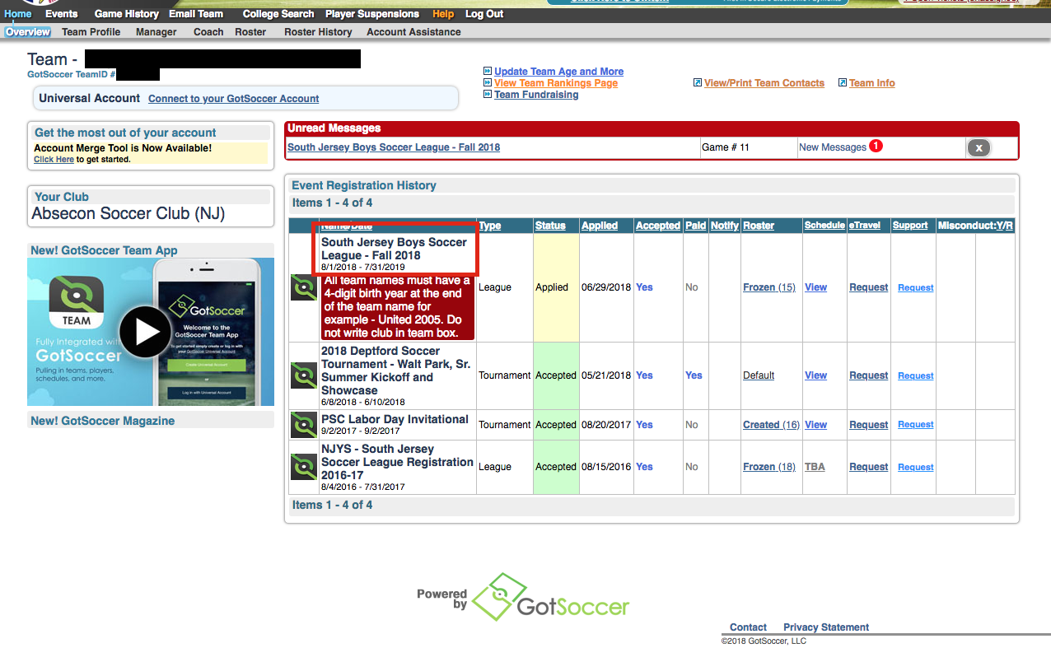
- Click on “Player ID numbers” and change it from Default to Us Club.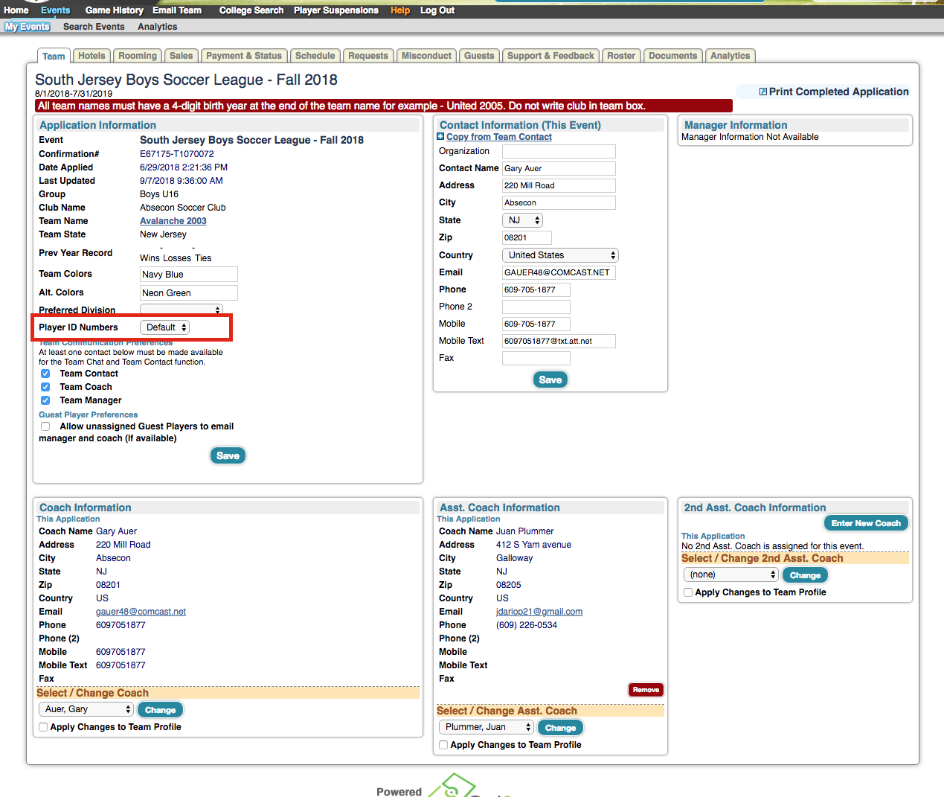

- Click “save” and your coaches/players should be corrected.
